TECH REPOSITORY
Project submitted in partial fulfillment of the requirements for the award of the degree of

BACHELOR OF TECHNOLOGY

IN
COMPUTER SCIENCE AND ENGINEERING
BY

B BHARATH (18C21A0504)
B RAHUL (18C21A0505)
R VENU (18C21A0540)

Under the Esteemed guidance of
Ms.MOUNIKA M.Tech
Assistant Professor


DEPARTMENT OF COMPUTER SCIENCE AND ENGINEERING

HOLY MARY INSTITUTE OF TECHNOLOGY & SCIENCE
(COLLEGE OF ENGINEERING)
(Approved by AICTE New Delhi, Permanently Affiliated to JNTU Hyderabad, Accredited by NAAC with ‘A’ Grade)
Bogaram (V), Keesara (M), Medchal District -501 301.

2021 - 2022

HOLY MARY INSTITUTE OF TECHNOLOGY & SCIENCE

(COLLEGE OF ENGINEERING)
(Approved by AICTE New Delhi, Permanently Affiliated to JNTU Hyderabad, Accredited by NAAC with ‘A’ Grade)
Bogaram (V), Keesara (M), Medchal Dist-501301.

DEPARTMENT OF COMPUTER SCIENCE AND ENGINEERING


CERTIFICATE

This is to certify that the mini project entitled “TECH REPOSITORY” is being submitted by B.BHARATH (18C21A0504), B RAHUL (18C21A0505), R.VENU (18C21A0540), in Partial fulfillment of the academic requirements for the award of the degree of Bachelor of Technology in “COMPUTER SCIENCE AND ENGINEERING” HOLY MARY INSTITUTE OF TECHNOLOGY & SCIENCE, JNTU Hyderabad during the year 2019- 2020.

INTERNAL GUIDE HEAD OF THE DEPARTMENT

Ms. MOUNIKA M.Tech DR .B.NARSIMHA M.Tech, Ph.D.
Assistant Professor Professor & HoD
Dept. of Computer Science & Engineering. Dept. of Computer Science & Engineering

EXTERNAL EXAMINER
ACKNOWLEDGEMENT

The satisfaction and euphoria that accompany the successful completion of any task would be incomplete without the mention of the people who made it possible, who’s constant guidance and encouragement crowns all effort with success.

I take this opportunity to express my profound gratitude and deep regards to My Guide Ms.Mounika, Assistant Professor, Dept. of Computer Science & Engineering, Holy Mary Institute of Technology & Science for his / her exemplary guidance, monitoring and constant encouragement throughout the project work.

My special thanks to Dr. B. Narsimha, Head of the Department, Dept. of Computer Science & Engineering, Holy Mary Institute of Technology & Science who has given an immense support throughout the course of the project.

I also thank to Dr. P. Bhaskara Reddy, the honorable Director of my college Holy Mary Institute of Technology & Science for providing me the opportunity to carry out this work.

At the outset, I express my deep sense of gratitude to the beloved Chairman A. Siddartha Reddy of Holy Mary Institute of Technology & Science, for giving me the opportunity to complete my course of work

I am obliged to staff members of Holy Mary Institute of Technology & Science for the valuable information provided by them in their respective fields. I am grateful for their cooperation during the period of my assignment.

Last but not the least I thank ALMIGHTY and My Parents, and Friends for their constant encouragement without which this assignment would not be possible.

B BHARATH (18C21A0504)
B RAHUL (18C21A0505)
R VENU (18C21A0540)

DECLARATION

This is to certify that the work reported in the present project titled “TECH REPOSITORY ” is a record of work done by me in the Department of Computer Science & Engineering, Holy Mary Institute of Technology and Science.
No part of the thesis is copied from books/journals/internet and wherever the portion is taken, the same has been duly referred in the text the reported are based on the project work done entirely by me not copied from any other source.

B BHARATH (18C21A0504)

B RAHUL (18C21A0505)

R VENU (18C21A0540)

Contents
- INTRODUCTION. PAGE NO
  - Problem Definition…………………………………………………...1
  - Existing System………………………………………………………1
  - Proposed System……………………………………………………...1
- LITERATURE SURVEY
2.1. JAVA…………………………………………………………………2-3
2.2. ANDROID…………………………………………………………….3
2.2.1 About Native code…………………………………………………...4
2.2.2 Creating an android project………………………………………….4-5
2.2.3 To create an AVD with the AVD manager………………………….5
2.2.4 To Create or Modify a Launch Configuration………………………5-6

- System requirements and Analysis
  - Software Requirements……………………………………………….7
3.2 Hardware Requirements………………………………………………7
3.3 Feasibility Study………………………………………………………7-8
  - Economical feasibility…………………………………………………8
3.5 Operational feasibility…………………………………………………8
3.6 Technical feasibility……………………………………………………8

- SYSTEM DESIGN
  - DFDs………………………………………………………………….9-10
  - E-R Diagrams………………………………………………………..11
    - UML Diagrams………………………………………......11
    - Use case diagrams…………………………………......12
    - Object diagram………………………………………...12
    - Class Diagram……………………………………….....12
    - Activity Diagrams………………………………….......13
    - Statechat Diagrams……………………………………..14
    - Sequence Diagram……………………………………...15
    - Collaboration Diagram…………………………………16
    - Component Diagram……………………………………16
4.2.10 Deployment diagram…………………………………...16

- SYSTEM IMPLEMENTATION
5.1 Algorithms& code snippets………………………………….17-36
5.2 Methods of implementation………………………………….37

- SYSTEM TESTING.
  - Unit testing………………………………………………….38
  - Integration testing…………………………………………...38
  - Validation testing…………………………………………… 38
6.4 System testing………………………………………………..39
- SCREENSHOTS/RESULTS…………………………………….40-44
- CONCLUSION…………………………………………………….45
- BIBLIOGRAPHY………………………………………………….46
1 .INTRODUCTION
Tech Repository is a mobile application and its main theme is to provide maximum knowledge of technical side in programming This include the programming data, syntaxes and other useful data in famous programming languages like c , c++ , Java , php and many more. Many other applications contain the data of any single programming language, thus “Tech Repository” over comes this drawback and provides all at once.
It provides the user flexibility for gaining knowledge through technical side This application is going to be developed in android platform.
Existing System:
There are many existing applications similar to this but consists only single subject.
Proposed System:
This application contains multiple subjects Where user is not required to search for different applications for different programming languages.
Module Description:
Works under the android interface.

.

2. LITERATURE SURVEY
2.1. JAVA
Java is an object-oriented language, and is very similar to C++. Java is simplified to eliminate language features that cause common programming errors. Java source code files are compiled into a format called byte code, which can then be executed by a Java interpreter .Features being
- Platform Independent
The programs written on one platform can run on any platform provided the platform must have the JVM.
- Portable
The feature Write-once-run-anywhere makes the java language portable provided that the system must have interpreter for the JVM.
- Simple
Programs are easy to write and debug because java does not use the pointers explicitly. It also has the automatic memory allocation and de allaocation system.
- Multithreaded
Multithreading means a single program having different threads executing independently at the same time.
- Robust
Java has the strong memory allocation and automatic garbage collection mechanism. It provides the powerful exception handling and type checking mechanism as compare to other programming languages.
- Object Oriented
To be an Object Oriented language, any language must follow at least the four characteristics.
- Inheritance
- Encapsulation
- Polymorphism
- Dynamic binding
- Distributed
The widely used protocols like HTTP and FTP are developed in java. Internet programmers can call functions on these protocols and can get access to the files from any remote machine on the internet rather than writing codes on their local system.
- Secure
All the programs in java are run under an area known as the sand box. Security manager determines the accessibility options of a class like reading and writing a file to the local disk.
- High Performance
In the beginning interpretation of byte code resulted in slow performance but the advance version of JVM uses the adaptive and just in time compilation technique that improves the performance.
- Integrated
Java is an interpreted language as well. Programs run directly from the source code.
2.2. ANDROID
Android is a software stack for mobile devices that includes an operating system, middleware and key applications. The android SDK provides the tools and APIs necessary to begin developing applications on the Android platform using the Java programming language.
The Android SDK includes a comprehensive set of development tools. These include a debugger, libraries, a handset emulator (based on QEMU), documentation, sample code, and tutorials. Currently supported development platforms include x86-architecture computers running Linux (any modern desktop Linux distribution), Mac OS X 10.4.8 or later, Windows XP or Vista. The officially supported integrated development environment (IDE) is Eclipse (3.2 or later) using the Android Development Tools (ADT) Plugin, though developers may use any text editor to edit Java and XML files then use command line tools to create, build and debug Android applications.

2.2.1 About Native code:
Libraries written in C and other languages can be compiled to ARM native code and installed, but the Native Development Kit is not yet officially supported by Google. Native classes can be called from Java code running under the Dalvik VM using the System. Load Library call, which is part of the standard Android Java classes.
2.2.2 Creating an android project
The ADT plugin provides a New Project Wizard that you can use to quickly create a new Android project (or a project from existing code). To create a new project:
- Select File > New > Project.
- Select Android > Android Project, and click Next.
- Select the contents for the project:
- Enter a Project Name. This will be the name of the folder where your project is created.
- Under Contents, select Create new project in workspace. Select your project workspace location.
- Under Target, select an Android target to be used as the project's Build Target. The Build Target specifies which Android platform you'd like your application built against.
- Unless you know that you'll be using new APIs introduced in the latest SDK, you should select a target with the lowest platform version possible, such as Android 1.1.
- Under Properties, fill in all necessary fields.:
Enter an Application name. This is the human-readable title for your application — the name that will appear on the Android device.
- Enter a Package name. This is the package namespace (following the same rules as for packages in the Java programming language) where all your source code will reside.
- Select Create Activity (optional, of course, but common) and enter a name for your main Activity class.
- Enter a Min SDK Version. This is an integer that indicates the minimum API Level required to properly run your application. Entering this here automatically sets the min Sdk Version attribute in the <uses-sdk> of your Android Manifest file. If you're unsure of the appropriate API Level to use, copy the API Level listed for the Build Target you selected in the Target tab.
- Click Finish.
2.2.3 To create an AVD with the AVD manager:
- Select Window > Android SDK and AVD Manager, or click the Android SDK and AVD Manager icon (a black device) in the Eclipse toolbar.
- In the Virtual Devices panel, you'll see a list of existing AVDs. Click New to create a new AVD.
- Fill in the details for the AVD.
- Give it a name, a platform target, an SD card image (optional), and a skin (HVGA is default).
- Click Create AVD.
When you first run a project as an Android Application, ADT will automatically create a run configuration. The default run configuration will launch the default project Activity and use automatic target mode for device selection (with no preferred AVD).
2.2.4 To Create or Modify a Launch Configuration
Follow these steps as appropriate for your Eclipse version:
- Open the run configuration manager.
- In Eclipse 3.3 ,select Run > Open Run Dialog (or Open Debug Dialog)
- In Eclipse 3.4 (Ganymede), select Run > Run Configurations (or Debug Configurations)
- Expand the Android Application item and create a new configuration or open an existing one.
2.3. SQLITE
SQLite is an ACID-compliant embeddedrelational database management system contained in a relatively small C programming library. The source code for SQLite is in the public domain.

2.3.1Design
Unlike client-server database management systems, the SQLite engine is not a standalone process with which the application program communicates. Instead, the SQLite library is linked in and thus becomes an integral part of the application program. The library can also be called dynamically. The application program uses SQLite's functionality through simple function calls, which reduces latency in database access as function calls within a single process are more efficient than inter-process communication.
2.3.2Features
SQLite implements most of the SQL-92 standard for SQL but it lacks some features. A standalone program called sqlite3 is provided which can be used to create a database, define tables within it, insert and change rows, run queries and manage an SQLite database file. SQLite is a popular choice for local/client SQL storage within a web browser and within a rich internet application framework. This may be because SQLite's dynamically typed storage matches the web browser's core languages of Javascript and XML. SQLite uses an unusual type system for an SQL-compatible DBMS. Instead of assigning a type to a column as in most SQL database systems, types are assigned to individual values; in language terms it is dynamically typed.

3.SYSTEM ANALYSIS

3.1 SOFTWARE REQUIREMENTS:
- Java
- Android SDK 1.5 or later
- Eclipse Ganymede IDE
- Operating System can be Windows XP, LINUX and Mac etc.
3.2 HARDWAREREQUIREMENTS:
This application requires a smart mobile phone and with android operating system.
1. PROCESSOR : (min) P2 Processor
2. RAM : (min) 128
3. HARD DISK : 100 MB
3.3 FEASIBILITY STUDY
The next step in analysis is to verify the feasibility of the proposed system. “All projects are feasible given unlimited resources and infinite time“. But in reality both resources and time are scarce. Project should confirm to time bounce and should be optimal in there consumption of resources.

Feasibility has applied to File Encryption Technique pertains to the following areas:
- Technical feasibility
- Operational feasibility
- Economical feasibility

TECHNICAL FEASIBILITY:
As we are developing Technique Application on Java 2 platform edition which is an open source and free of cost. Once we started developing this application in Java 2 platform edition then there is no need of purchasing any special software or application software for support. Java itself provides all necessary functionalities and resources for developing Tech Repository Application. For Example ,GUI can be developed by AWT or Swing Framework which is much available in Java.
OPERATIONAL FEASIBILITY:
To determine the operational feasibility of the system we should take into consideration the awareness level of the users. Users who are using this Technique don’t require much knowledge of how to use. Just Users should have basic concept of what is File Encryption Technique? Every thing will be understood by user once he sees the application.
ECONOMIC FEASIBILITY:
To decide whether a project is economically feasible, or not we have to consider various factors as:
- Cost benefit analysis
- Long-term returns
- Maintenance costs

4. SYSTEM DESIGN

4.2 DATA FLOW DIAGRAMS
A data-flow diagram (DFD) is a graphical representation of the "flow" of data through an information system. DFDs can also be used for the visualization of data processing (structured design).
On a DFD, data items flow from an external data source or an internal data store to an internal data store or an external data sink, via an internal process. The idea behind the explosion of a process into more process is that understanding at one level of detail is exploded into greater detail at the next level. This is done further explosion is necessary and an adequate amount of detail is described for analyst to understand the process.
`A DFD is also known as a “bubble chart” has the purpose of clarifying system requirements and identifying major transformations that will become programs in system design.
So it is the starting point of the design to the lowest level of detail. A DFD consists of a series of bubbles joined by data flows in the system.
4.2.1 DFD Symbols
In the DFD, there are four symbols
- A Square defines a source or destination of system data.
- An arrow identifies data flow. It is the pipeline through which the information flows.
- A circle or a bubble represents a process that transforms incoming data flow into outgoing data flows.
- An open rectangle is a data store ,data at rest or a temporary repository of data
Process that transforms data flow

Source or destination of data

Data flow

Data store

DataFlow Diagram :

Select syntax

Data input
Search Technology
Tech Repository
datatypes

Functions or
variables

Tech Repository System Process

4.3 UNIFIED MODELING LANGUAGE (UML)
The unified modeling is a standard language for specifying, visualizing, constructing and documenting the system and its components is a graphical language which provides a vocabulary and set of semantics and rules. The UML focuses on the conceptual and physical representation of the system. It captures the decisions and understandings about systems that must be constructed. It is used to understand, design, configure and control information about the systems.
Depending on the development culture, some of these artifacts are treated more or less formally than others. Such artifacts are not only the deliverables of a project; they are also critical in controlling, measuring, and communicating about a system during its development and after its deployment.
The UML addresses the documentation of a system's architecture and all of its details. The UML also provides a language for expressing requirements and for tests. Finally, the UML provides a language for modeling the activities of project planning and release management.

Building Blocks of the UML:
The vocabulary of the UML encompasses three kinds of building blocks:
- Things
- Relationships
- Diagrams
Things are the abstractions that are first-class citizens in a model; relationships tie these things together; diagrams group interesting collections of things.

Things in the UML:

There are four kinds of things in the UML:
- Structural things
- Behavioral things
- Grouping things
- Annotational things
- Usecase Diagram
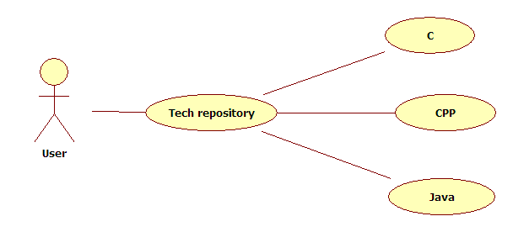

Class Diagram:

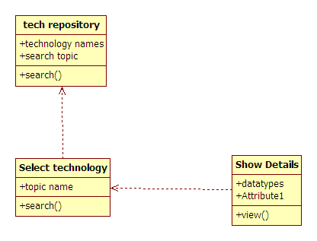

Activity Diagram:

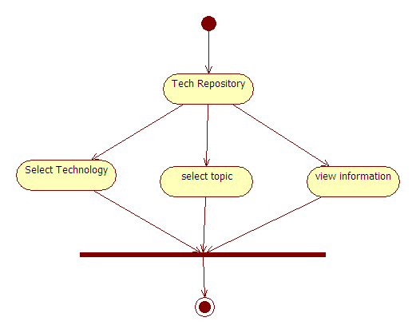

Statechart Diagram:
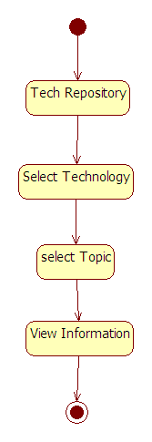

Sequence Diagram:

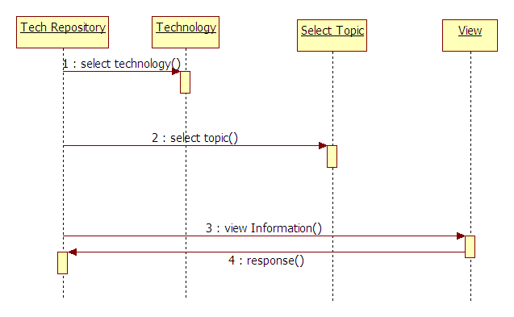

Collaboration Diagram:
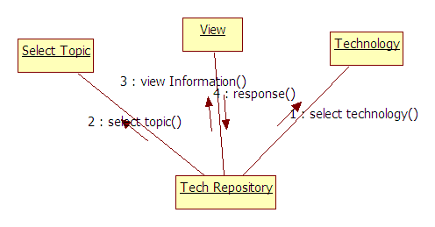

Component Diagram:

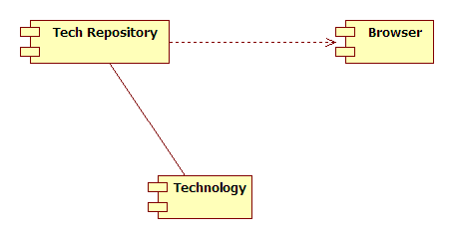

5. SYSTEM CODING & IMPLEMENTATION

5.1 Coding:
package com.example.dd;
import java.util.ArrayList;
import android.app.Activity;
import android.os.Bundle;
import android.view.View;
import android.view.Window;
import android.widget.AdapterView;
import android.widget.AdapterView.OnItemSelectedListener;
import android.widget.ArrayAdapter;
import android.widget.HorizontalScrollView;
import android.widget.ImageView;
import android.widget.Spinner;

public class CActivity extends Activity {
Spinner sp;
ImageView img1,img2,img3,img4,img5,img6,img7,img8;
ArrayList<String> aa=new ArrayList<String>();
HorizontalScrollView hsv;
@Override
protected void onCreate(Bundle savedInstanceState) {
requestWindowFeature(Window.FEATURE_NO_TITLE);
super.onCreate(savedInstanceState);
setContentView(R.layout.activity_c);
sp=(Spinner)findViewById(R.id.spinner1);
img2=(ImageView)findViewById(R.id.imageView2);
img1=(ImageView)findViewById(R.id.imageView1);
img3=(ImageView)findViewById(R.id.imageView3);
img4=(ImageView)findViewById(R.id.imageView4);
img5=(ImageView)findViewById(R.id.imageView5);
img6=(ImageView)findViewById(R.id.imageView6);
img7=(ImageView)findViewById(R.id.imageView7);
img8=(ImageView)findViewById(R.id.imageView8);
hsv=(HorizontalScrollView)findViewById(R.id.horizontalScrollView1);
aa.add("SELECT");
aa.add("Basic Syntax");
aa.add("Data Types");
aa.add("Functions");
aa.add("Variables");
aa.add("Loops");
aa.add("Goto-Break");
ArrayAdapter<String> adap=new ArrayAdapter<String>(getApplicationContext(), android.R.layout.simple_spinner_item, aa);
sp.setAdapter(adap);
sp.setOnItemSelectedListener(new OnItemSelectedListener() {

@Override
public void onItemSelected(AdapterView<?> parent, View view,
int position, long id) {
// TODO Auto-generated method stub
String s=sp.getSelectedItem().toString();
if(s.equals("SELECT"))
{

}
else if(s.equals("Basic Syntax"))
{
hsv.scrollTo(hsv.getLeft(),hsv.getTop());
img4.setVisibility(View.VISIBLE);
img5.setVisibility(View.VISIBLE);
img6.setVisibility(View.VISIBLE);
img7.setVisibility(View.GONE);
img8.setVisibility(View.GONE);
img1.setImageResource(R.drawable.cb1);
img2.setImageResource(R.drawable.cb2);
img3.setImageResource(R.drawable.cb3);
img4.setImageResource(R.drawable.cb4);
img5.setImageResource(R.drawable.cb5);
img6.setImageResource(R.drawable.cb6);
}
else if(s.equals("Goto-Break"))
{
hsv.scrollTo(hsv.getLeft(),hsv.getTop());
img4.setVisibility(View.VISIBLE);
img5.setVisibility(View.VISIBLE);
img6.setVisibility(View.VISIBLE);
img7.setVisibility(View.GONE);
img8.setVisibility(View.GONE);
img1.setImageResource(R.drawable.cg1);
img2.setImageResource(R.drawable.cg2);
img3.setImageResource(R.drawable.cg3);
img4.setImageResource(R.drawable.cg4);
img5.setImageResource(R.drawable.cg5);
img6.setImageResource(R.drawable.cg6);
}
else if(s.equals("Data Types"))
{
hsv.scrollTo(hsv.getLeft(),hsv.getTop());
img4.setVisibility(View.VISIBLE);
img5.setVisibility(View.VISIBLE);
img6.setVisibility(View.VISIBLE);
img7.setVisibility(View.VISIBLE);
img8.setVisibility(View.VISIBLE);
img1.setImageResource(R.drawable.cd1);
img2.setImageResource(R.drawable.cd2);
img3.setImageResource(R.drawable.cd3);
img4.setImageResource(R.drawable.cd4);
img5.setImageResource(R.drawable.cd5);
img6.setImageResource(R.drawable.cd3);
img7.setImageResource(R.drawable.cd4);
img8.setImageResource(R.drawable.cd5);

}
else if(s.equals("Variables"))
{
hsv.scrollTo(hsv.getLeft(),hsv.getTop());
img1.setImageResource(R.drawable.cv1);
img2.setImageResource(R.drawable.cv2);
img3.setImageResource(R.drawable.cv3);
img4.setVisibility(View.GONE);
img5.setVisibility(View.GONE);
img6.setVisibility(View.GONE);
img7.setVisibility(View.GONE);
img8.setVisibility(View.GONE);

}
else if(s.equals("Functions"))
{
hsv.scrollTo(hsv.getLeft(),hsv.getTop());
img4.setVisibility(View.VISIBLE);
img5.setVisibility(View.VISIBLE);
img1.setImageResource(R.drawable.cf1);
img2.setImageResource(R.drawable.cf2);
img3.setImageResource(R.drawable.cf3);
img4.setImageResource(R.drawable.cf4);
img5.setImageResource(R.drawable.cf5);
img6.setVisibility(View.GONE);
img7.setVisibility(View.GONE);
img8.setVisibility(View.GONE);
}
else if(s.equals("Loops"))
{
hsv.scrollTo(hsv.getLeft(),hsv.getTop());
img6.setVisibility(View.VISIBLE);
img7.setVisibility(View.VISIBLE);
img1.setImageResource(R.drawable.cl1);
img2.setImageResource(R.drawable.cl2);
img3.setImageResource(R.drawable.cl3);
img4.setImageResource(R.drawable.cl4);
img5.setImageResource(R.drawable.cl5);
img6.setImageResource(R.drawable.cl6);
img7.setImageResource(R.drawable.cl7);
img8.setVisibility(View.GONE);

}
}

@Override
public void onNothingSelected(AdapterView<?> parent) {
// TODO Auto-generated method stub

}
});

}
}
package com.example.dd;

import java.util.ArrayList;

import android.app.Activity;
import android.os.Bundle;
import android.view.Menu;
import android.view.MenuItem;
import android.view.View;
import android.view.Window;
import android.widget.AdapterView;
import android.widget.ArrayAdapter;
import android.widget.HorizontalScrollView;
import android.widget.ImageView;
import android.widget.Spinner;
import android.widget.AdapterView.OnItemSelectedListener;

public class CppActivity extends Activity {
Spinner sp,sp1;
ImageView img1,img2,img3,img4,img5,img6,img7,img8;
ArrayList<String> aa=new ArrayList<String>();
ArrayList<String> aa1=new ArrayList<String>();
HorizontalScrollView hsv;
@Override
protected void onCreate(Bundle savedInstanceState) {
requestWindowFeature(Window.FEATURE_NO_TITLE);
super.onCreate(savedInstanceState);
setContentView(R.layout.activity_cpp);
sp=(Spinner)findViewById(R.id.spinner1);
sp1=(Spinner)findViewById(R.id.spinner2);
hsv=(HorizontalScrollView)findViewById(R.id.horizontalScrollView1);
img2=(ImageView)findViewById(R.id.imageView2);
img1=(ImageView)findViewById(R.id.imageView1);
img3=(ImageView)findViewById(R.id.imageView3);
img4=(ImageView)findViewById(R.id.imageView4);
img5=(ImageView)findViewById(R.id.imageView5);
img6=(ImageView)findViewById(R.id.imageView6);
img7=(ImageView)findViewById(R.id.imageView7);
img8=(ImageView)findViewById(R.id.imageView8);

aa.add("SELECT");
aa.add("Overview");
aa.add("Basic Syntax");
aa.add("Data Types");

aa.add("Functions");
aa.add("Loops");
aa.add("Stmt");
aa.add("Oops");

aa1.add("SELECT");
aa1.add("Encapsulation");
aa1.add("Abstraction");
aa1.add("Inheritance");
aa1.add("Polymorphisam");
aa1.add("Interfaces");
ArrayAdapter<String> adap=new ArrayAdapter<String>(getApplicationContext(), android.R.layout.simple_spinner_item, aa);
sp.setAdapter(adap);
ArrayAdapter<String> adap1=new ArrayAdapter<String>(getApplicationContext(), android.R.layout.simple_spinner_item, aa1);
sp1.setAdapter(adap1);
sp.setOnItemSelectedListener(new OnItemSelectedListener() {

@Override
public void onItemSelected(AdapterView<?> parent, View view,
int position, long id) {
// TODO Auto-generated method stub
String s=sp.getSelectedItem().toString();
if(s.equals("SELECT"))
{

}
else if(s.equals("Oops"))
{
hsv.scrollTo(hsv.getLeft(),hsv.getTop());
sp1.setVisibility(View.VISIBLE);
}
else if(s.equals("Overview"))
{
hsv.scrollTo(hsv.getLeft(),hsv.getTop());
sp1.setVisibility(View.GONE);
img4.setVisibility(View.VISIBLE);
img5.setVisibility(View.VISIBLE);
img6.setVisibility(View.GONE);
img7.setVisibility(View.GONE);
img8.setVisibility(View.GONE);

img1.setImageResource(R.drawable.cppo1);
img2.setImageResource(R.drawable.cppo2);
img3.setImageResource(R.drawable.cppo3);
img4.setImageResource(R.drawable.cppo4);
img5.setImageResource(R.drawable.cppo5);
}
else if(s.equals("Basic Syntax"))
{
hsv.scrollTo(hsv.getLeft(),hsv.getTop());
sp1.setVisibility(View.GONE);

img4.setVisibility(View.VISIBLE);
img5.setVisibility(View.VISIBLE);
img6.setVisibility(View.VISIBLE);

img1.setImageResource(R.drawable.cppb1);
img2.setImageResource(R.drawable.cppb2);
img3.setImageResource(R.drawable.cppb3);
img4.setImageResource(R.drawable.cppb4);
img5.setImageResource(R.drawable.cppb5);
img6.setImageResource(R.drawable.cppb6);

img7.setVisibility(View.GONE);
img8.setVisibility(View.GONE);
}
else if(s.equals("Stmt"))
{
hsv.scrollTo(hsv.getLeft(),hsv.getTop());
sp1.setVisibility(View.GONE);

img4.setVisibility(View.VISIBLE);
img5.setVisibility(View.VISIBLE);
img6.setVisibility(View.VISIBLE);

img1.setImageResource(R.drawable.cpps1);
img2.setImageResource(R.drawable.cpps2);
img3.setImageResource(R.drawable.cpps3);
img4.setImageResource(R.drawable.cpps4);
img5.setImageResource(R.drawable.cpps5);
img6.setImageResource(R.drawable.cpps6);

img7.setVisibility(View.GONE);
img8.setVisibility(View.GONE);
}
else if(s.equals("Functions"))
{
hsv.scrollTo(hsv.getLeft(),hsv.getTop());
sp1.setVisibility(View.GONE);

img4.setVisibility(View.VISIBLE);
img5.setVisibility(View.VISIBLE);
img6.setVisibility(View.VISIBLE);

img1.setImageResource(R.drawable.cppf1);
img2.setImageResource(R.drawable.cppf2);
img3.setImageResource(R.drawable.cppf3);
img4.setImageResource(R.drawable.cppf4);
img5.setImageResource(R.drawable.cppf5);
img6.setImageResource(R.drawable.cppf6);

img7.setVisibility(View.GONE);
img8.setVisibility(View.GONE);
}
else if(s.equals("Data Types"))
{
hsv.scrollTo(hsv.getLeft(),hsv.getTop());
sp1.setVisibility(View.GONE);
img4.setVisibility(View.VISIBLE);
img1.setImageResource(R.drawable.cppd1);
img2.setImageResource(R.drawable.cppd2);
img3.setImageResource(R.drawable.cppd3);
img4.setImageResource(R.drawable.cppd4);

img5.setVisibility(View.GONE);
img6.setVisibility(View.GONE);
img7.setVisibility(View.GONE);
img8.setVisibility(View.GONE);

}
else if(s.equals("Variables"))
{
hsv.scrollTo(hsv.getLeft(),hsv.getTop());
sp1.setVisibility(View.GONE);
img4.setVisibility(View.VISIBLE);
img5.setVisibility(View.VISIBLE);
img6.setVisibility(View.VISIBLE);
img7.setVisibility(View.VISIBLE);

img1.setImageResource(R.drawable.cppv1);
img2.setImageResource(R.drawable.cppv2);
img3.setImageResource(R.drawable.cppv3);
img4.setImageResource(R.drawable.cppv4);
img5.setImageResource(R.drawable.cppv5);
img6.setImageResource(R.drawable.cppv6);
img7.setImageResource(R.drawable.cppv7);

img8.setVisibility(View.GONE);

}

else if(s.equals("Loops"))
{
hsv.scrollTo(hsv.getLeft(),hsv.getTop());
sp1.setVisibility(View.GONE);

img4.setVisibility(View.VISIBLE);
img5.setVisibility(View.VISIBLE);
img6.setVisibility(View.VISIBLE);
img7.setVisibility(View.VISIBLE);
img8.setVisibility(View.VISIBLE);
img1.setImageResource(R.drawable.cppl1);
img2.setImageResource(R.drawable.cppl2);
img3.setImageResource(R.drawable.cppl3);
img4.setImageResource(R.drawable.cppl4);
img5.setImageResource(R.drawable.cppl5);
img6.setImageResource(R.drawable.cppl6);
img7.setImageResource(R.drawable.cppl7);
img8.setImageResource(R.drawable.cppl8);

}
}

@Override
public void onNothingSelected(AdapterView<?> parent) {
// TODO Auto-generated method stub

}
});
sp1.setOnItemSelectedListener(new OnItemSelectedListener() {

@Override
public void onItemSelected(AdapterView<?> parent, View view,
int position, long id) {
// TODO Auto-generated method stub
String s=sp1.getSelectedItem().toString();
if(s.equals("SELECT"))
{

}

else if(s.equals("Encapsulation"))
{
hsv.scrollTo(hsv.getLeft(),hsv.getTop());
img1.setImageResource(R.drawable.cppe1);
img2.setImageResource(R.drawable.cppe2);
img3.setImageResource(R.drawable.cppe3);
img4.setImageResource(R.drawable.cppe3);

img4.setVisibility(View.VISIBLE);
img5.setVisibility(View.GONE);
img6.setVisibility(View.GONE);
img7.setVisibility(View.GONE);
img8.setVisibility(View.GONE);

}
else if(s.equals("Abstraction"))
{
hsv.scrollTo(hsv.getLeft(),hsv.getTop());
img4.setVisibility(View.GONE);
img5.setVisibility(View.GONE);

img1.setImageResource(R.drawable.cppa1);
img2.setImageResource(R.drawable.cppa2);
img3.setImageResource(R.drawable.cppa3);

img6.setVisibility(View.GONE);
img7.setVisibility(View.GONE);
img8.setVisibility(View.GONE);

}
else if(s.equals("Inheritance"))
{
hsv.scrollTo(hsv.getLeft(),hsv.getTop());
img4.setVisibility(View.VISIBLE);
img1.setImageResource(R.drawable.cppi1);
img2.setImageResource(R.drawable.cppi2);
img3.setImageResource(R.drawable.cppi3);
img4.setImageResource(R.drawable.cppi4);
img5.setImageResource(R.drawable.cppi5);

img5.setVisibility(View.VISIBLE);
img6.setVisibility(View.GONE);
img7.setVisibility(View.GONE);
img8.setVisibility(View.GONE);

}
else if(s.equals("Polymorphisam"))
{
hsv.scrollTo(hsv.getLeft(),hsv.getTop());

img4.setVisibility(View.VISIBLE);
img5.setVisibility(View.VISIBLE);
img6.setVisibility(View.VISIBLE);
img7.setVisibility(View.GONE);
img8.setVisibility(View.GONE);
img1.setImageResource(R.drawable.cppp1);
img2.setImageResource(R.drawable.cppp2);
img3.setImageResource(R.drawable.cppp3);
img4.setImageResource(R.drawable.cppp4);
img5.setImageResource(R.drawable.cppp5);
img6.setImageResource(R.drawable.cppp6);

}
else if(s.equals("Interfaces"))
{
hsv.scrollTo(hsv.getLeft(),hsv.getTop());
img4.setVisibility(View.GONE);

img5.setVisibility(View.GONE);
img6.setVisibility(View.GONE);
img7.setVisibility(View.GONE);
img8.setVisibility(View.GONE);
img1.setImageResource(R.drawable.cppin1);
img2.setImageResource(R.drawable.cppin2);
img3.setImageResource(R.drawable.jin3);
}
}

@Override
public void onNothingSelected(AdapterView<?> parent) {
// TODO Auto-generated method stub

}
});
}}

5.2 Method of Implementation
Implementation literally means to put into effect or to carry out. The system implementation phase of the software deals with the translation of the design specifications into the source code. The ultimate goal of the implementation is to write the source code and the internal documentation so that it can be verified easily. The code and documentation should be written in a manner that eases debugging, testing and modification. System flowcharts, sample run on packages, sample output etc. Is part of the implementation?
An effort was made to satisfy the following goals in order specified.
• Minimization of Response Time.
• Clarity and Simplicity of the Code.
• Minimization of Hard-Coding.
Various types of bugs were discovered while debugging the modules. These ranged from logical errors to failure on account of various processing cases.

6. TESTING AND VALIDATION
The development of software systems involves of a series of production activities where opportunities for injection of human fallibilities are enormous. Errors may begin to occur at the very inception of the process where the objectives may be erroneously or imperfectly specified, as well as in later design and development stages. Because of human inability to perform and communicate with perfection, software development is accompanied by a quality assurance activity.

TESTING TECHNIQUES
Testing is the process of executing a program with the intention of finding errors. The various test strategies used for testing the software are as follows.
6.1 Unit Testing
Unit testing focuses on verification effort on the smallest unit of the software design module. The main goal is to make sure that every source statement and logic path has been executed correctly at least once. The output of this stage is the source code.
6.2 Integration Testing
In Integration testing, we find errors that have occurred during the integration. After testing each module, which is then integrated into subsystems and then to form the entire system on which integration testing is performed. The goal of testing is to detect the design errors, while focusing on the testing the interconnection between modules.

6.3 Validation Testing
This testing concentrates on confirming that the software is error-free in all respects. All the specified validations are verified and the software is subjected to hard-core testing. It also aims at determining the degree of deviation that exists in the software designed from the specification; they are listed out and are corrected.

6.4 System Testing
In this testing, the system is tested for the errors after coupling all the modules together The system is tested against the specified requirements to see if all the requirements are met and the system performs as specified by the requirements.

7.SCREENSHOTS
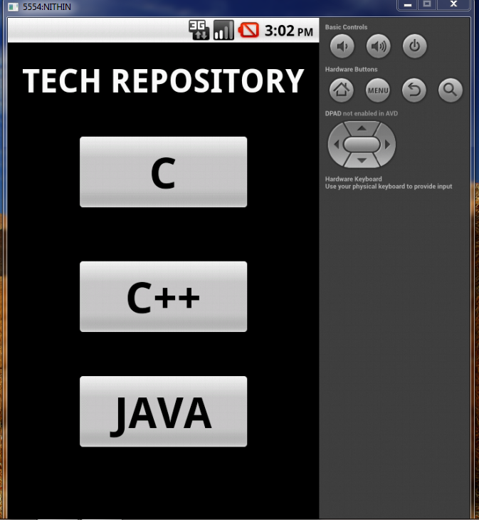

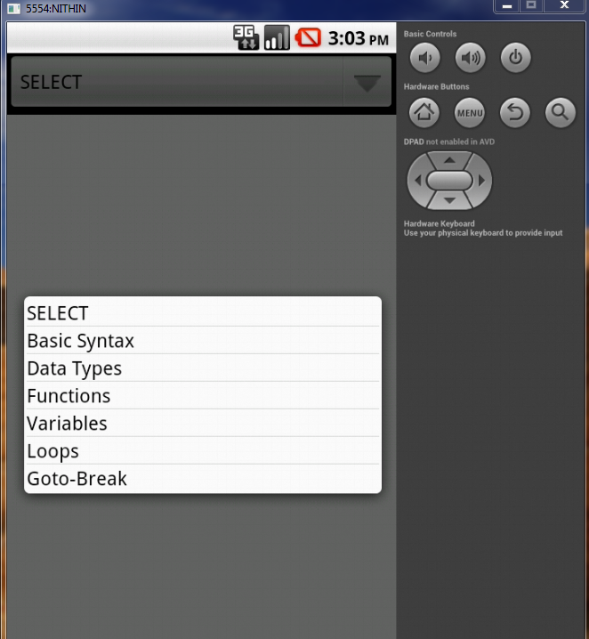

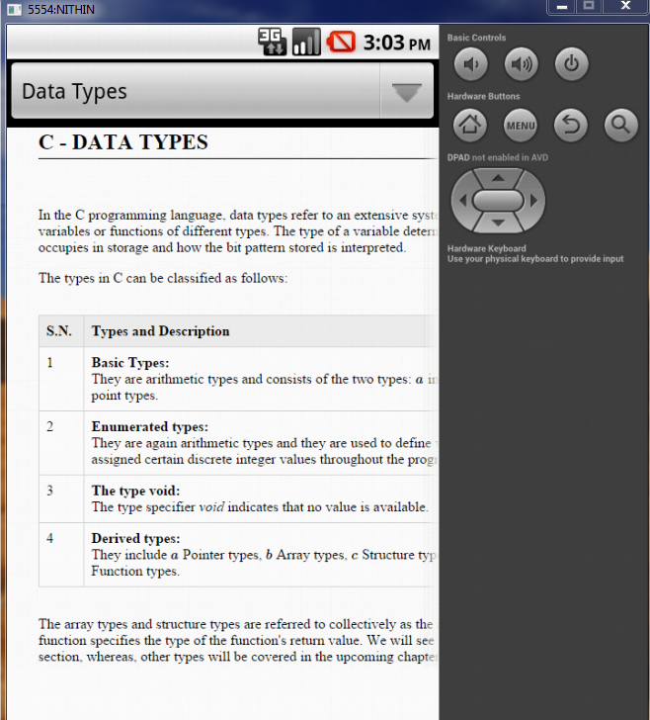

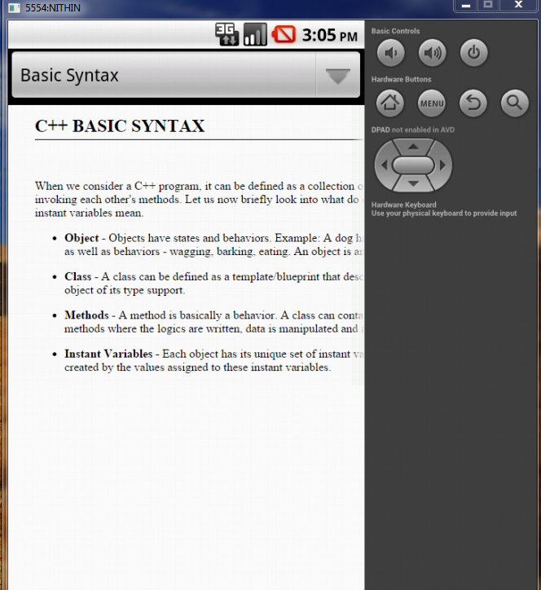

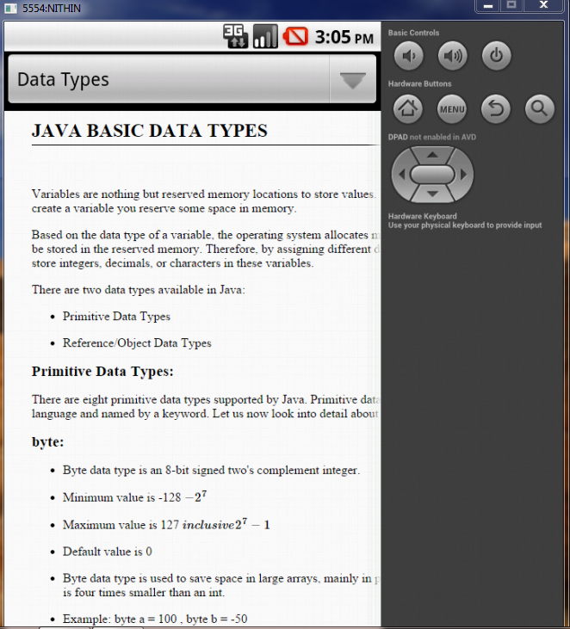

8. CONCLUSION

This application is used for getting technologies. It is a tool developed for android platform, which is used to search various technologies and their related information within the mobile. This is an advantage when compared to existing system because a single mobile piece is enough for deploying the application .As this is a mobile application one can easily search for required information. This makes this application efficient, convenient and easy to use along with providing maximum user satisfaction which is the key aspect for any developer.

9.BIBLIOGRAPHY

- Herbert Schildt.2008 ,”Java Complete Reference”, Tata McGraw-Hill ,
7th Edition, pp.177-180 .
- GradyBooch,James Rambaugh.1998,“UnifiedModeling Language User Guide”, Addison Wesley Publishing, chapter 8-31.

WEBSITES: REFERRED URLS:
www.android.com http://developer.android.com/index.html
www.google.com http://en.wikipedia.org/wiki

